Contents
Overview 1
Technology Stack 1
Key Features 1
Features 3
1. User Authentication: Login and Dashboard Access 3
Sign In Page 3
Forgot Password 3
Admin Features 5
Admin Dashboard Overview 5
Dashboard Overview 5
Counsellor-Wise Performance Overview 6
Accessing Counsellor Details 6
Viewing Assigned Leads 7
Assigned Leads Table 7
Lead Details Explanation 8
Lead Details 8
Action: View Lead Details 8
Lead and Counsellor Details Modal 9
Reassign Lead to Counsellor 10
Reassign Lead Page 10
Add New Leads 11
Option 1: Add New Lead (Manual) 11
Option 2: Upload Leads via Excel 12
Create Counsellor Account 14
Create Counsellor Account Form 14
Account Creation Process 14
Password Update Requirement 15
Counsellor Dashboard 16
Assigned Leads Table 16
Joined Leads 17
11. Update Password & Counsellor Details 18
Update Password 18
Update Counsellor Details 19

LEAD MANANGEMENT

Overview
The Lead Management System is designed to streamline the process of managing leads within an organization. The system is built using a robust technology stack, including React for the frontend, Node.js and Express for the backend, and MySQL for data storage. It allows admins to efficiently manage leads and assign them to counsellors, ensuring a smooth flow of information and interactions between different stakeholders.

Technology Stack
- Frontend: React.js
- Backend: Node.js, Express.js
- Database: MySQL
- Other: Email service for automated notifications

Key Features
- Role-based Access: The system is accessible by two types of users:
  - Admin: Manages leads, assigns them to counsellors, and oversees system data through a dashboard.
  - Counsellor: Manages and interacts with leads assigned by the admin.
- Lead Management: Admins can add new leads and assign them to a specific counsellor based on criteria or availability.
- Counsellor Account Creation: Admins create counsellor accounts by providing their email and phone number. An automated email is sent to the counsellor with a temporary password, which must be updated upon first login.
- Dashboard: Admins have access to a dashboard displaying key metrics:
  - Total number of counsellors
  - Total number of leads
  - Number of leads marked as "interested"
  - Number of leads that have "joined"

Features

1. User Authentication: Login and Dashboard Access

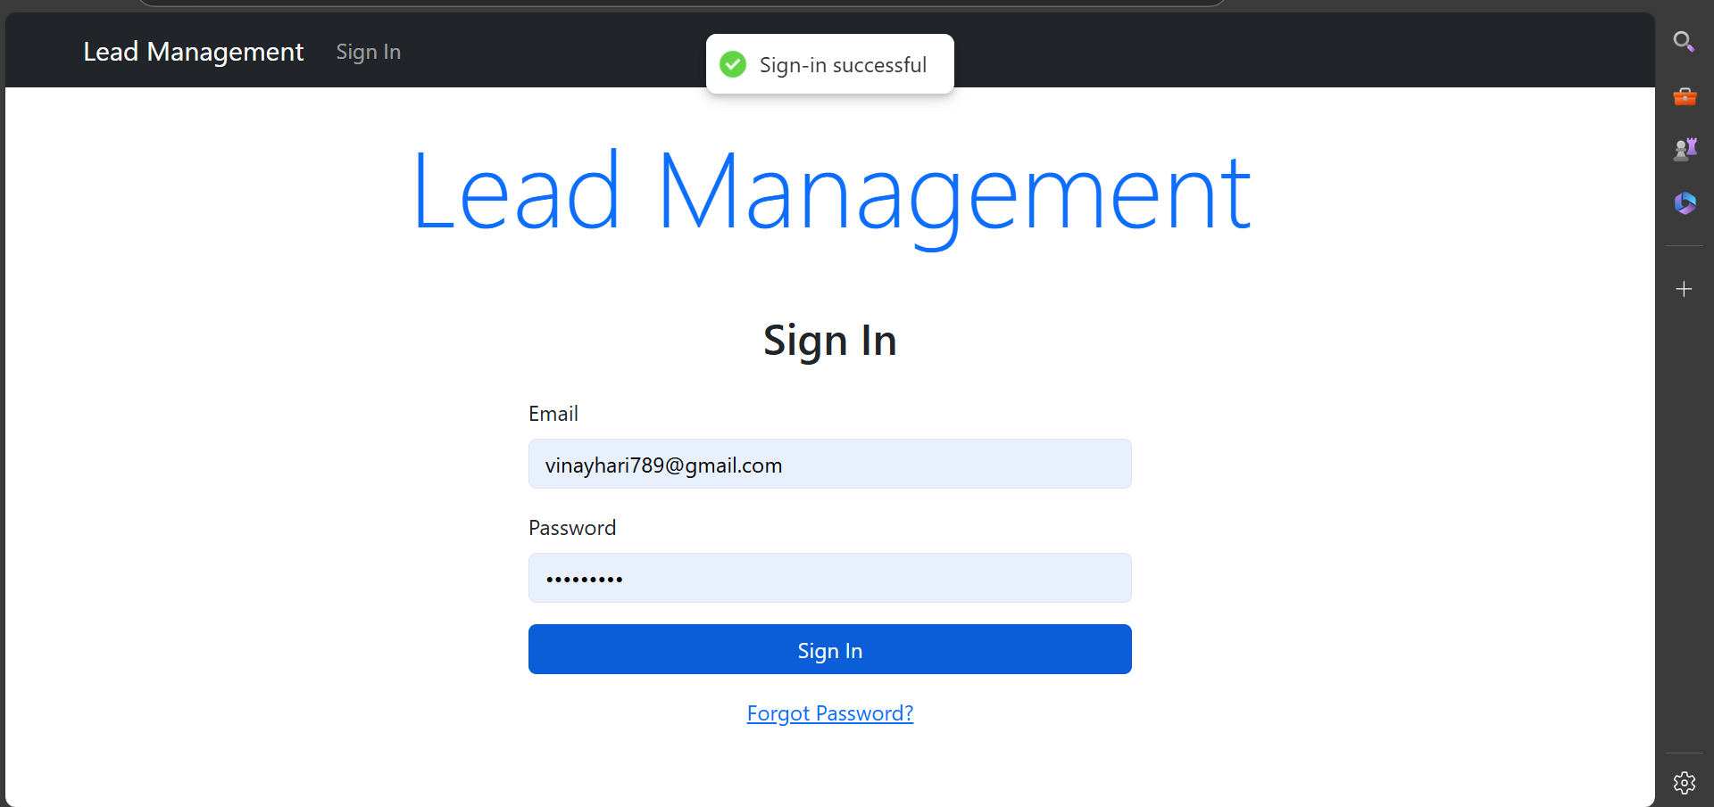

Sign In Page
- The home page of the Lead Management System is the Sign In page, where both admins and counsellors can log in using their credentials.
- The form includes fields for email and password, and it is common to both roles (admin and counsellor).

Role-based Redirect After Login
- Upon successful login, users are redirected to their respective dashboards:
  - Admin Dashboard: Admin users are directed to a dashboard where they can manage leads, counsellors, and view key data metrics.
  - Counsellor Dashboard: Counsellors are redirected to their own dashboard, where they can view and manage the leads assigned to them by the admin.

Forgot Password
- If a user forgets their password, they can click the Forgot Password link, which will prompt them to enter their registered email.
- The system will then trigger an email to the user with instructions to reset their password, ensuring a secure recovery process.
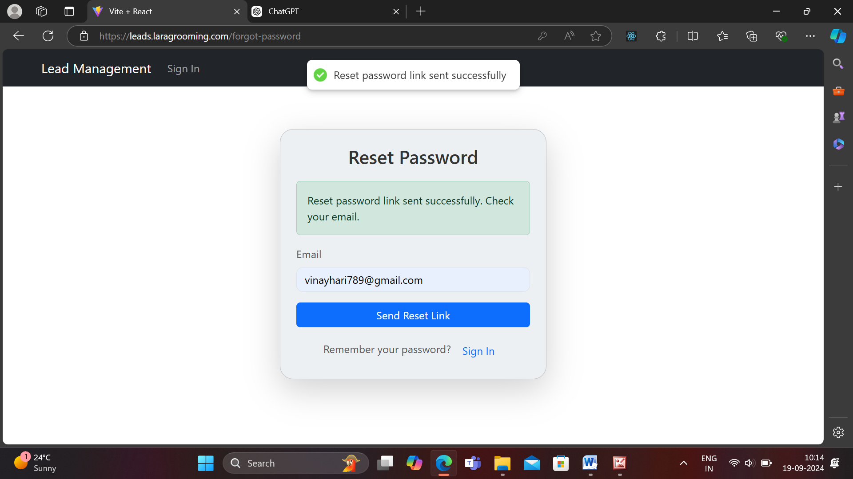
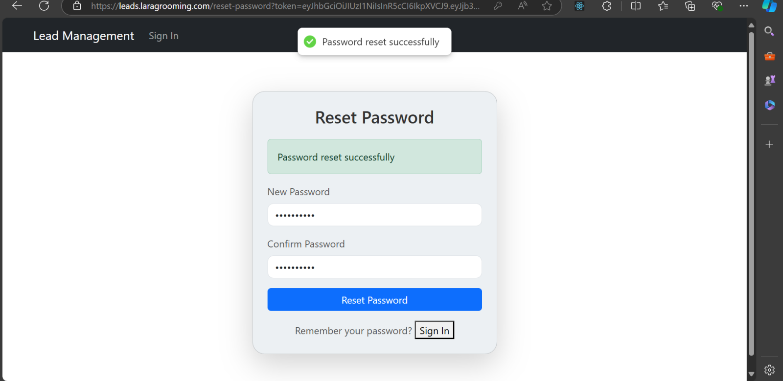

Login Feedback
- To enhance user experience, the system integrates React Hot Toast notifications:
  - A success toast is displayed when the user logs in successfully.
  - An error toast is displayed for failed login attempts (e.g., incorrect credentials or missing information).
This helps users receive instant feedback on their login attempt.

Admin Features

Admin Dashboard Overview
Upon successful login, the admin user is redirected to the Admin Dashboard. This dashboard provides a comprehensive view of the system's lead management data and allows the admin to track the performance of counsellors and the status of leads.

Dashboard Overview

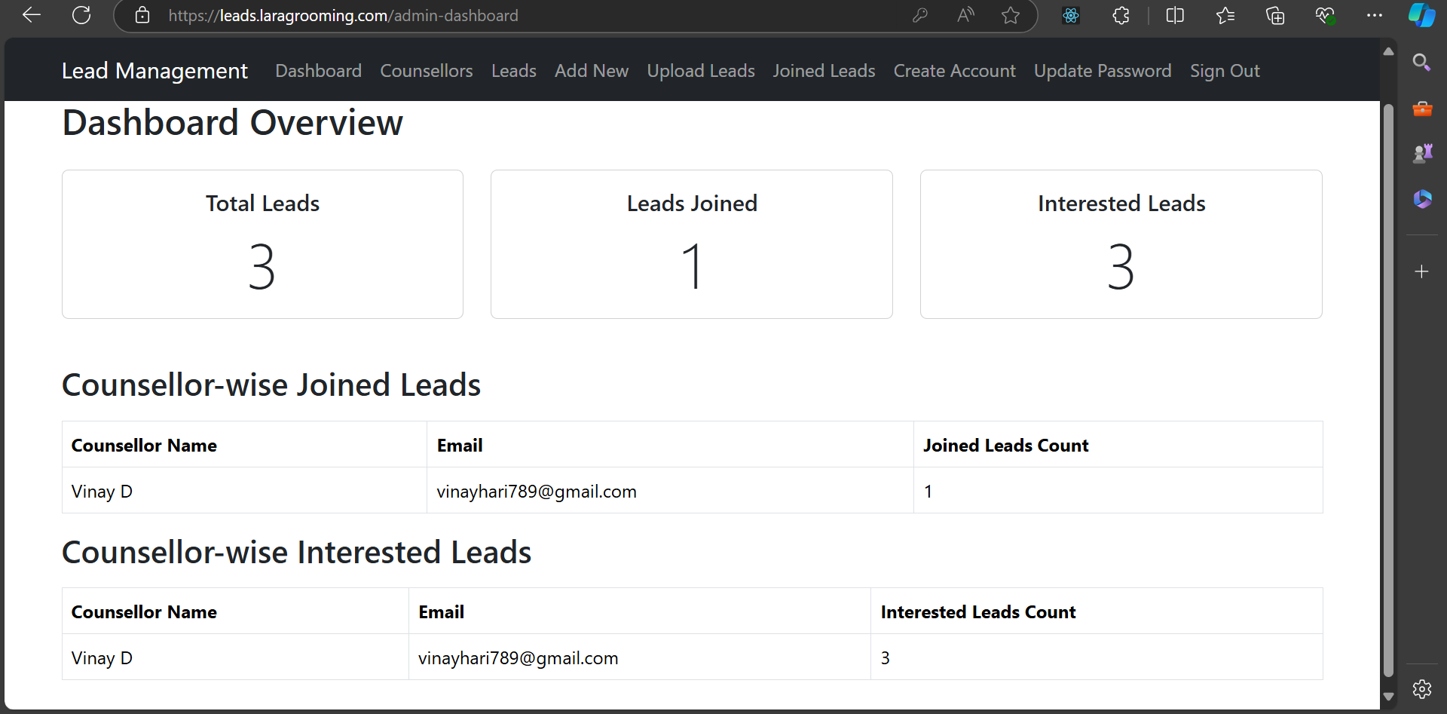
The admin dashboard displays various key metrics in a user-friendly format, enabling the admin to quickly assess the system's current status. The main sections of the dashboard include:
- Total Leads
  - Displays the total number of leads added to the system. This gives the admin an overview of the volume of leads currently being managed.
  - Example: Total Leads: 3
- Leads Joined
  - Shows the total number of leads that have joined or converted. This metric helps the admin track the effectiveness of the lead management process.
  - Example: Leads Joined: 1
- Interested Leads
  - Displays the total number of leads marked as "interested," indicating potential conversions. This helps the admin focus on leads that are more likely to convert.
  - Example: Interested Leads: 3

Counsellor-Wise Performance Overview
The dashboard also provides a breakdown of lead performance based on each counsellor’s interaction with their assigned leads. This section helps the admin evaluate individual counsellor performance in terms of both joined and interested leads.
- Counsellor-wise Joined Leads
  - Lists each counsellor along with their respective email and the number of leads they have successfully converted (joined).

- Counsellor-wise Interested Leads
  - Displays each counsellor's name, their email, and the number of leads that have expressed interest but haven’t yet joined. This gives insight into the counsellor's potential future conversions.

Accessing Counsellor Details
From the Admin Navbar, the admin can navigate to the Counsellors section to view the details of all counsellors within the system. This section provides a tabular view of counsellor information, enabling the admin to manage and track their performance effectively.
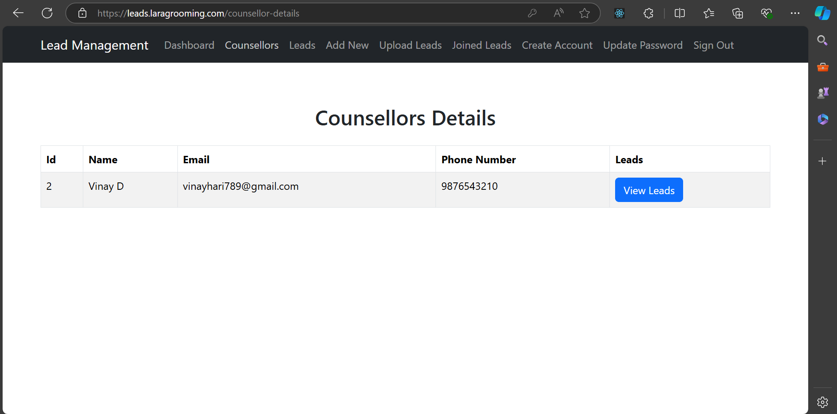

Counsellor Details Table
The main counsellor details are displayed in a table format with the following columns:
- Leads Column:
  - Each row has a View Leads button in the "Leads" column.
  - Clicking this button redirects the admin to a dedicated page that displays the leads assigned to the selected counsellor.

Viewing Assigned Leads
When the View Leads button is clicked for a counsellor, the admin is redirected to a detailed page showing the leads assigned to that specific counsellor. This page provides both counsellor details and a tabular representation of all assigned leads.

Counsellor Details Section
The page starts with key details about the counsellor:
- ID: Counsellor's unique identifier.
- Name: Counsellor's full name.
- Email: Counsellor's registered email address.
- Phone: Counsellor's phone number.
For example:
Counsellor Details
ID: 2
Name: Vinay D
Email: vinayhari789@gmail.com
Phone: 9876543210

Assigned Leads Table
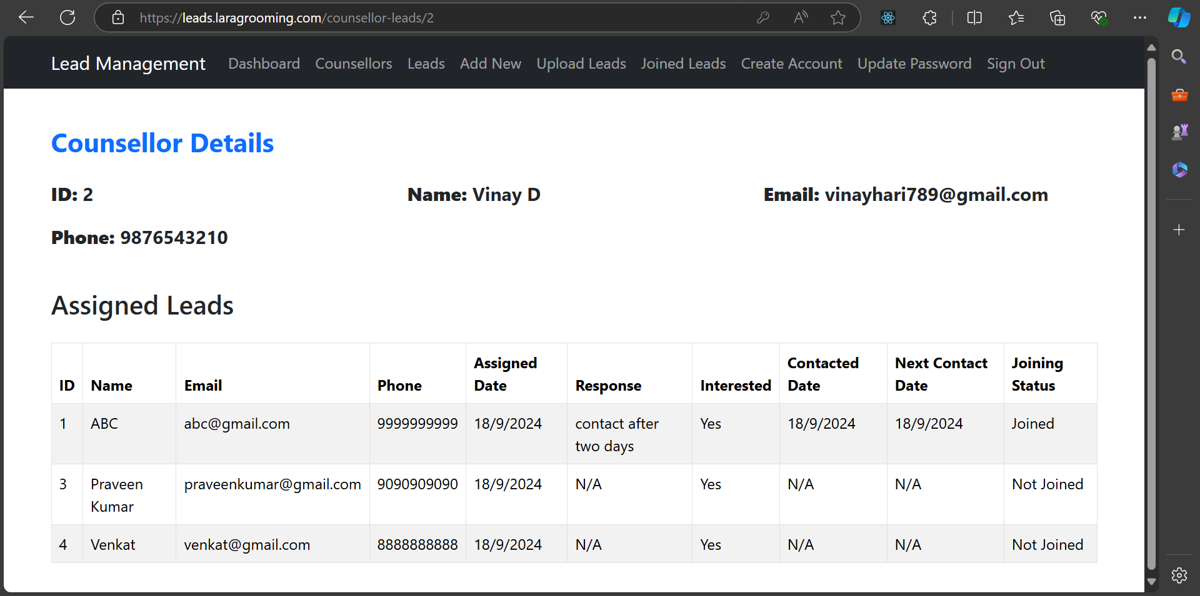
Below the counsellor details, the assigned leads are displayed in a table format. Each lead's information is listed with multiple data points, including response status and joining status.

Lead Details Explanation
- Response: Describes any specific feedback or instructions left by the counsellor.
- Interested: Indicates whether the lead has shown interest.
- Contacted Date: The date the counsellor last contacted the lead.
- Next Contact Date: The scheduled date for the next follow-up with the lead.
- Joining Status: Displays if the lead has joined or not.

Lead Details
To view and manage leads, the admin navigates to the Leads tab in the navbar. This section displays a comprehensive list of all leads, along with their assigned counsellors, in a table format. Admins can search and filter leads based on specific criteria and view detailed lead and counsellor information.

Lead and Counsellor List Table
The lead details are displayed in a table with the following columns:
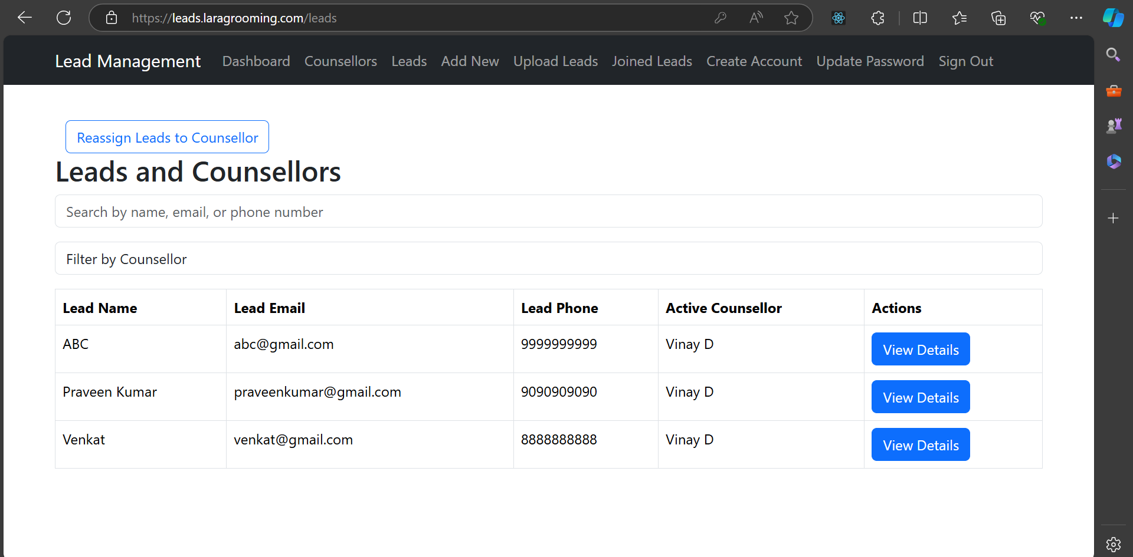
- Search Functionality: Admins can search leads by name, email, or phone number to quickly find specific leads.
- Filter by Counsellor: A filter option allows admins to view leads assigned to a particular counsellor.

Action: View Lead Details
In the Actions column, each row contains a View Details button. Clicking this button opens a modal with a detailed view of both the lead and their associated counsellors.

Lead and Counsellor Details Modal
The modal provides an overview of the lead’s information as well as the counsellor(s) who have been responsible for handling the lead. The active counsellor is highlighted in green to easily distinguish them.

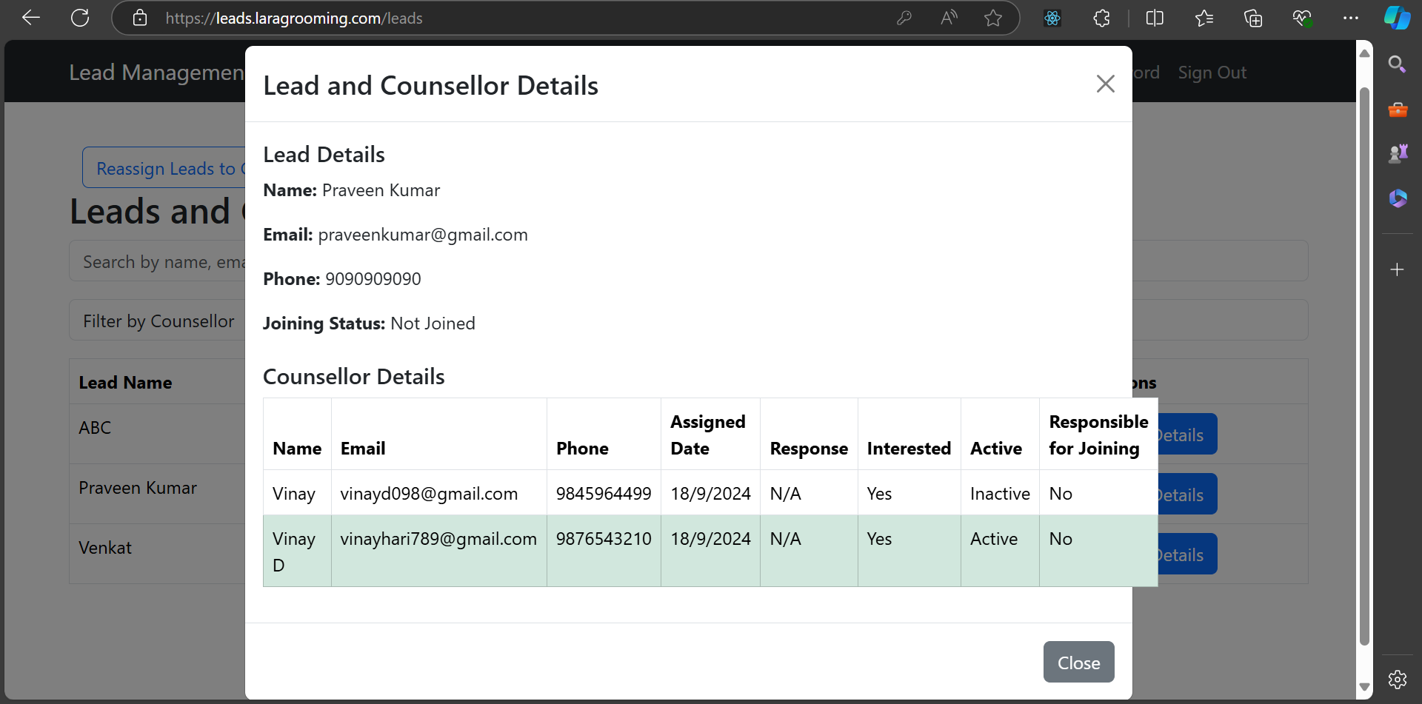

Lead Details
The lead’s personal and status information is displayed at the top of the modal:
- Name: Full name of the lead.
- Email: Lead’s email address.
- Phone: Lead’s contact number.
- Joining Status: Indicates whether the lead has joined (e.g., Joined, Not Joined).
Example:
- Active Counsellor: The current counsellor responsible for the lead is highlighted in green and marked as "Active."
- Response: Shows the most recent response or interaction between the counsellor and lead.
- Interested: Indicates whether the lead has expressed interest.
- Responsible for Joining: Identifies if the counsellor is responsible for converting the lead into a joined status.

Reassign Lead to Counsellor

Reassigning a Lead
To reassign a lead to a different counsellor, the admin can use the Reassign Lead to Counsellor functionality, which is accessible from the Leads and Counsellors page.

Reassign Lead to Counsellor Button
- Above the "Leads and Counsellors" table, there is a button labelled Reassign Lead to Counsellor.
- When the admin clicks this button, they are redirected to a new page where they can manage and reassign leads to other counsellors.

Reassign Lead Page
This page displays all leads in a table format along with their current (active) counsellor and a dropdown to select a new counsellor.
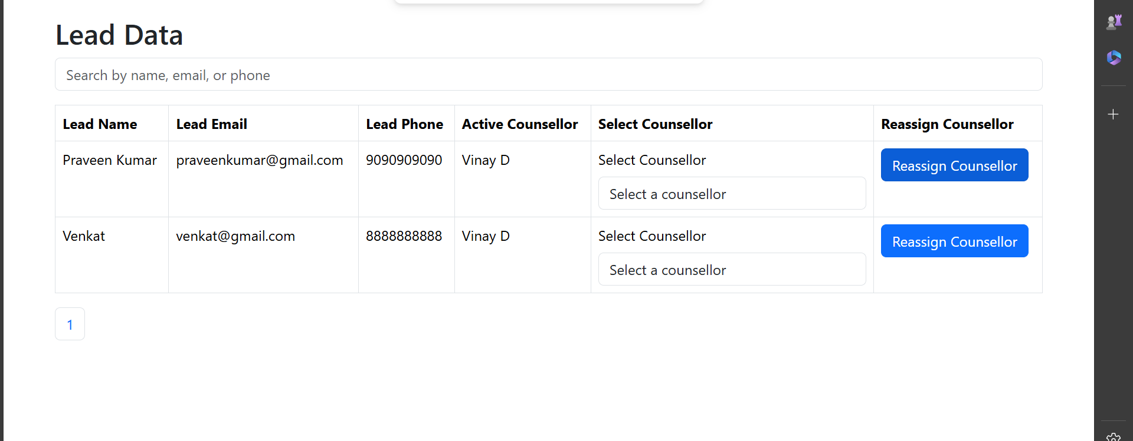
- Search Functionality: Admins can search leads by name, email, or phone number to quickly locate a specific lead.
- Active Counsellor: Shows the name and email of the counsellor currently responsible for the lead.
- Select Counsellor: This column contains a dropdown menu with all available counsellors' names and emails.

Select Counsellor Dropdown
The dropdown in the Select Counsellor column allows the admin to choose a new counsellor for a lead. The dropdown lists all available counsellors with the following format:
The admin selects the desired counsellor from this dropdown.

Reassign Counsellor Button
After selecting a new counsellor from the dropdown, the admin clicks the Reassign Counsellor button in the same row. This action updates the counsellor assignment for the lead.
- Once the reassignment is successful, a confirmation message (using React Hot Toast) is displayed to notify the admin of the successful reassignment.

Add New Leads
The system allows admins to add new leads using two methods: manually filling out a form or uploading an Excel sheet. This provides flexibility for handling individual leads and bulk imports.

Option 1: Add New Lead (Manual)
Admins can manually add new leads by clicking the Add New Lead option from the navbar. This redirects to a form where the admin can enter the lead details and assign the lead to a specific counsellor.

Add New Lead Form
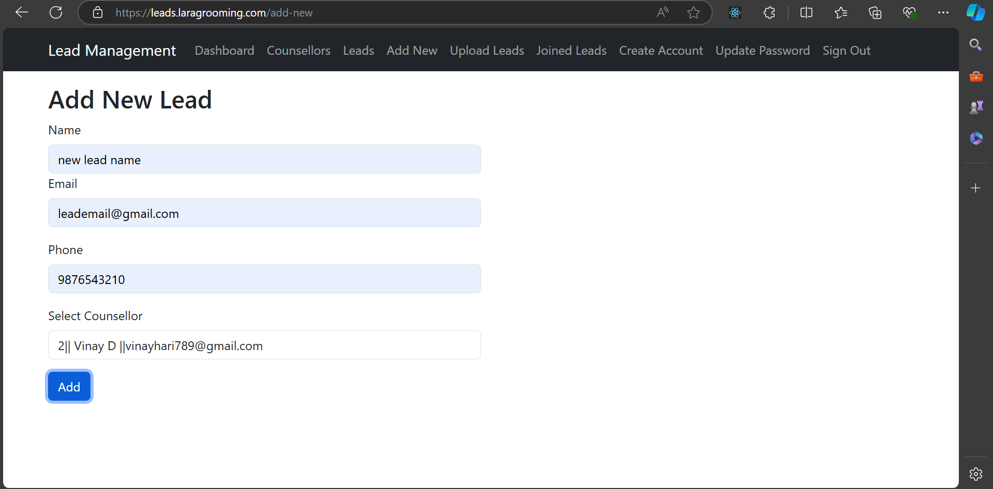
The form includes the following fields:
- Name: Full name of the lead.
- Email: Email address of the lead (must be in a valid format).
- Phone: Lead's phone number (used to check for duplicates).
- Select Counsellor: Dropdown list to assign the lead to an available counsellor.
Once the admin fills in all the necessary information, they can submit the form to add the lead to the system. The lead is then assigned to the selected counsellor, and the admin is notified of the successful lead creation.

Option 2: Upload Leads via Excel
For bulk lead imports, the admin can use the Upload Leads option from the navbar. This redirects to a page where admins can upload an Excel sheet with lead data.

Excel Sheet Format
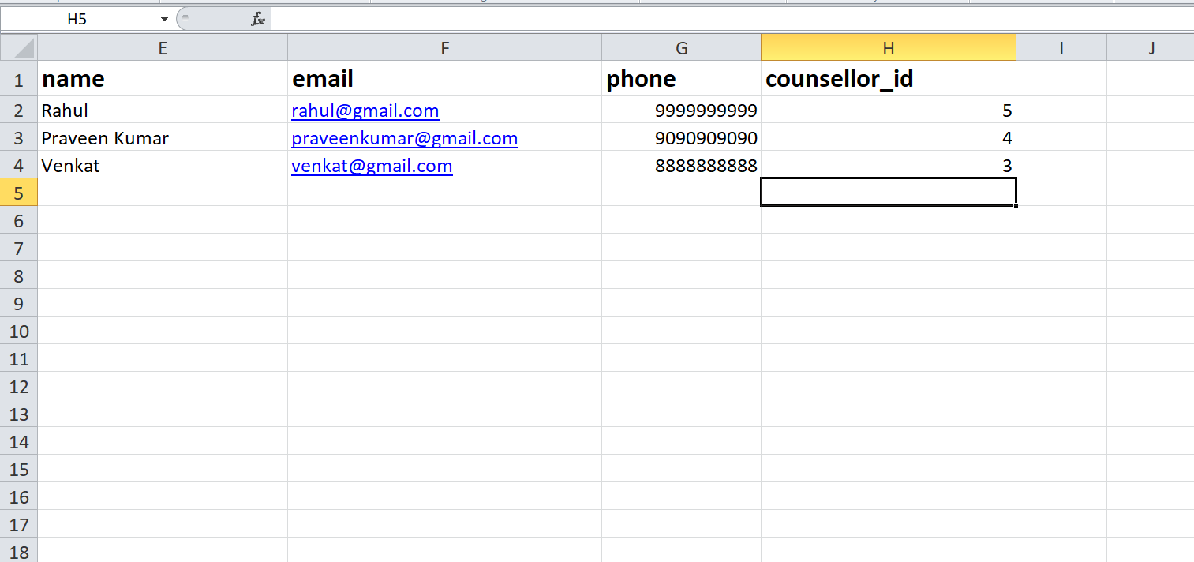
The page provides an Excel sheet template that the admin can download to ensure proper formatting. The sheet includes columns for lead information, including:
- Name
- Email
- Phone
- Counsellor ID

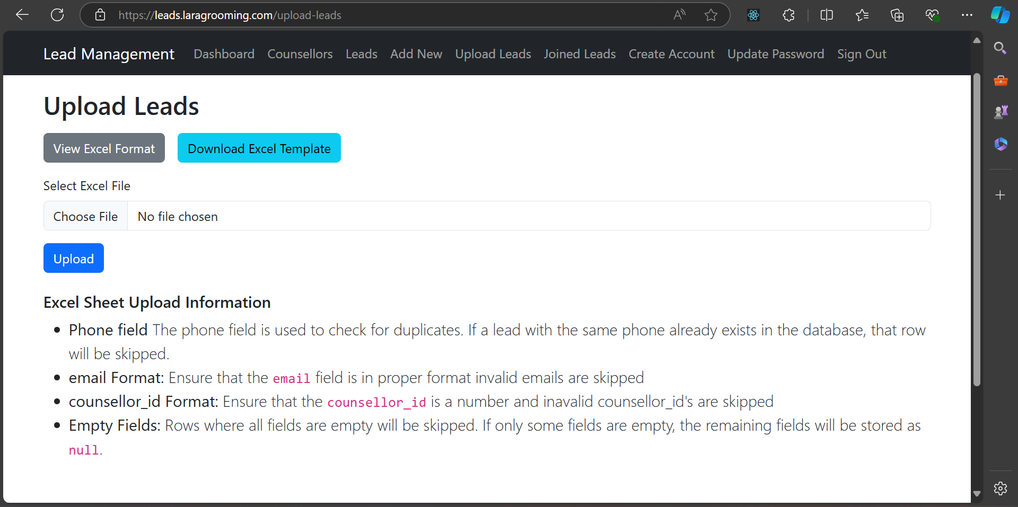

Excel Sheet Upload Rules
Before uploading, admins should follow these guidelines to ensure successful data import:
- Phone Field (Duplicate Check): The phone number is used to check for duplicates. If a lead with the same phone number already exists in the database, that row will be skipped.
- Email Format: Ensure the email is in a proper format. Rows with invalid email addresses will be skipped.
- Counsellor ID: The counsellor_id should be a valid number. If an invalid counsellor_id is provided, that row will be skipped.
- Empty Fields: Rows where all fields are empty will be skipped. If only some fields are empty, the remaining fields will be stored as null values.

Counsellor ID Reference
Below the upload rules, the admin can view a table of counsellors and their corresponding IDs. This helps the admin input the correct counsellor_id when filling out the Excel sheet.
Leads
This table provides the counsellor_id needed for assigning leads in the Excel sheet.

Uploading the Excel Sheet
Once the sheet is properly formatted and filled, the admin can upload the file. The system processes the sheet and adds valid leads to the database. If there are any skipped rows (due to invalid data), a summary will be provided to inform the admin.

Create Counsellor Account
Admins can create new counsellor accounts from the Create Account tab in the navbar. This feature streamlines the process of adding new counsellors to the system, automatically generating login credentials for them.

Create Counsellor Account Form
When the admin selects Create Account from the navbar, they are presented with a form to input the following details:
- Email: The email address of the new counsellor.
- Phone Number: The counsellor's contact phone number.
After entering the information, the admin clicks the Create Account button to generate the new counsellor account.

Account Creation Process
- Upon successful creation, the system automatically generates an account for the counsellor with a dummy password.
- An email is sent to the counsellor containing:
  - Their email address (username).
  - The dummy password for their initial login.
The counsellor can then use these credentials to log in to the system for the first time.
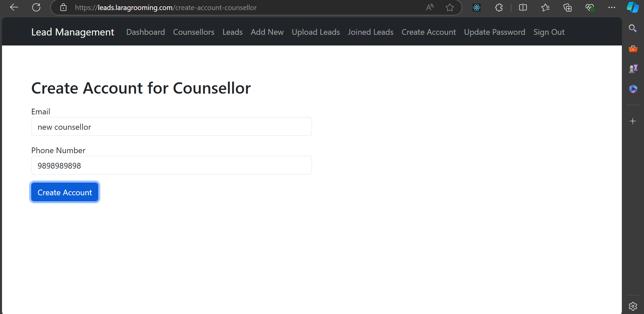

Password Update Requirement
For security purposes, counsellors must update their password upon their first login. They will be prompted to change the dummy password to a new one of their choosing. Until this update is completed, they will not be able to access any of the counsellor-specific features in the system.

Counsellor Dashboard
When a counsellor logs into the system, they are redirected to the Counsellor Dashboard, which provides an overview of all the leads assigned to them. The dashboard displays the leads in a table format and highlights leads that require immediate attention.

Assigned Leads Table
The table contains the following columns, displaying relevant lead information:
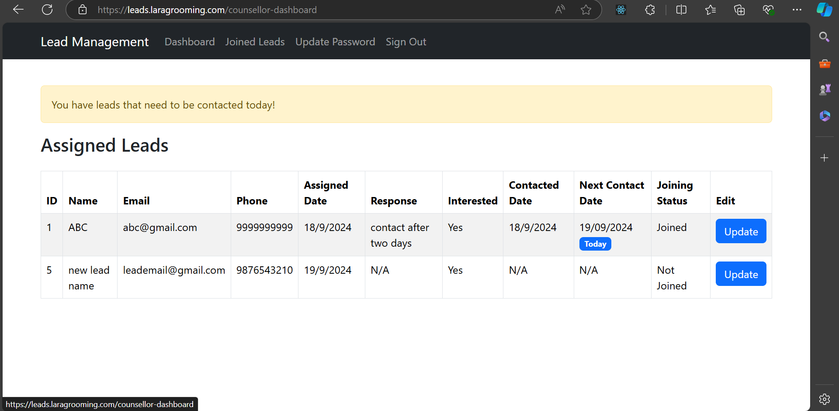

Leads to be Contacted Today
- If any lead’s Next Contact Date matches the current date, it is displayed with a blue badge labeled "Today" under the Next Contact Date column.
- The system also shows a notification at the top of the table stating:
"You have leads that need to be contacted today!"
This reminder ensures that counsellors are aware of the leads requiring immediate follow-up.

Lead Details in the Table
- Response: Displays the most recent interaction or status update with the lead.
- Interested: Indicates whether the lead has shown interest in the services.
- Next Contact Date: Specifies the date for the next planned contact with the lead.
- Joining Status: Reflects the lead's current status (e.g., Joined, Not Joined).
- Edit: Each row has an Edit button, allowing the counsellor to update the lead’s information or response directly from the table.

Counsellor Action
- Counsellors can click the Update button to modify the lead details, update responses, or adjust the contact schedule.
- They should pay close attention to leads marked with "Today" to ensure timely follow-ups, increasing the chances of conversion.
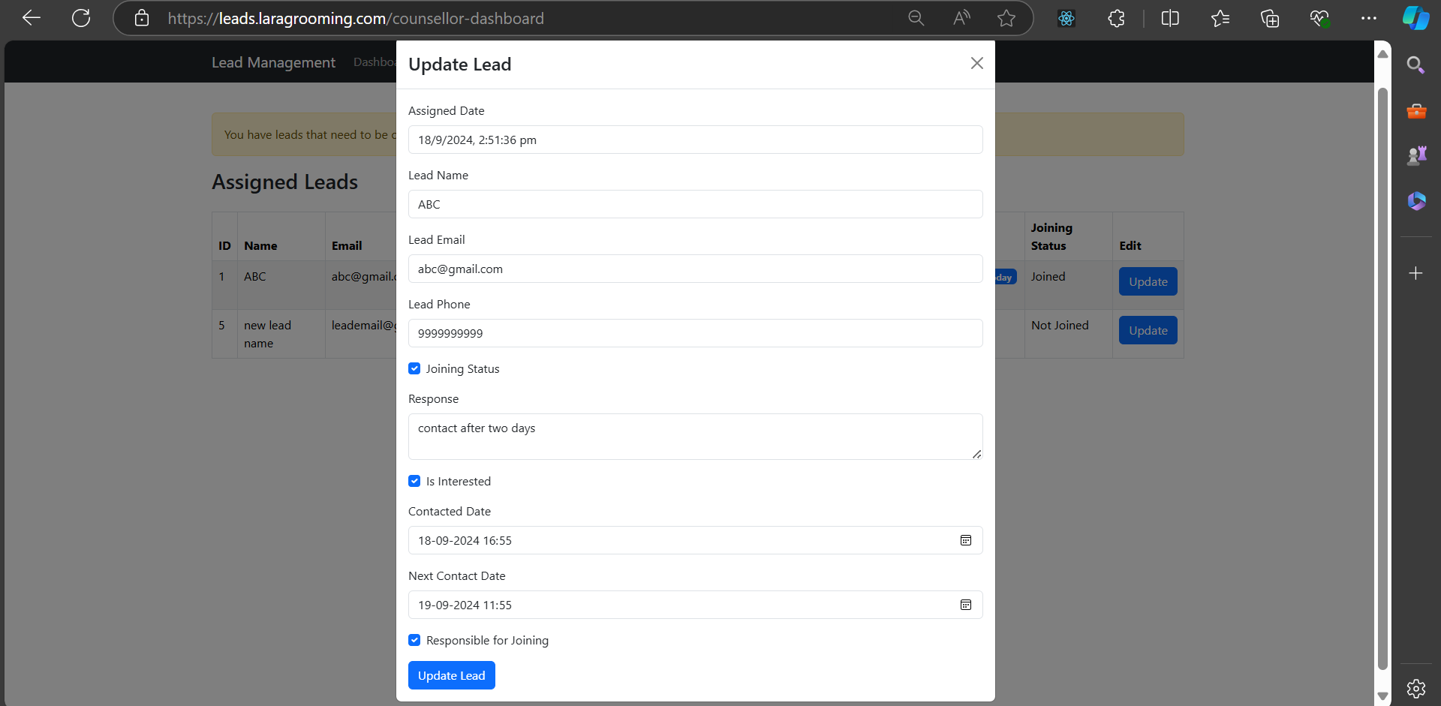

Joined Leads
The Joined Leads section allows counsellors to view a list of all leads who have successfully joined. This option is available in the counsellor's navbar and redirects to a table that displays relevant information about joined leads.

Joined Leads Table
The table contains the following columns:
This section helps counsellors track all the leads that have officially joined and manage follow-ups if needed.
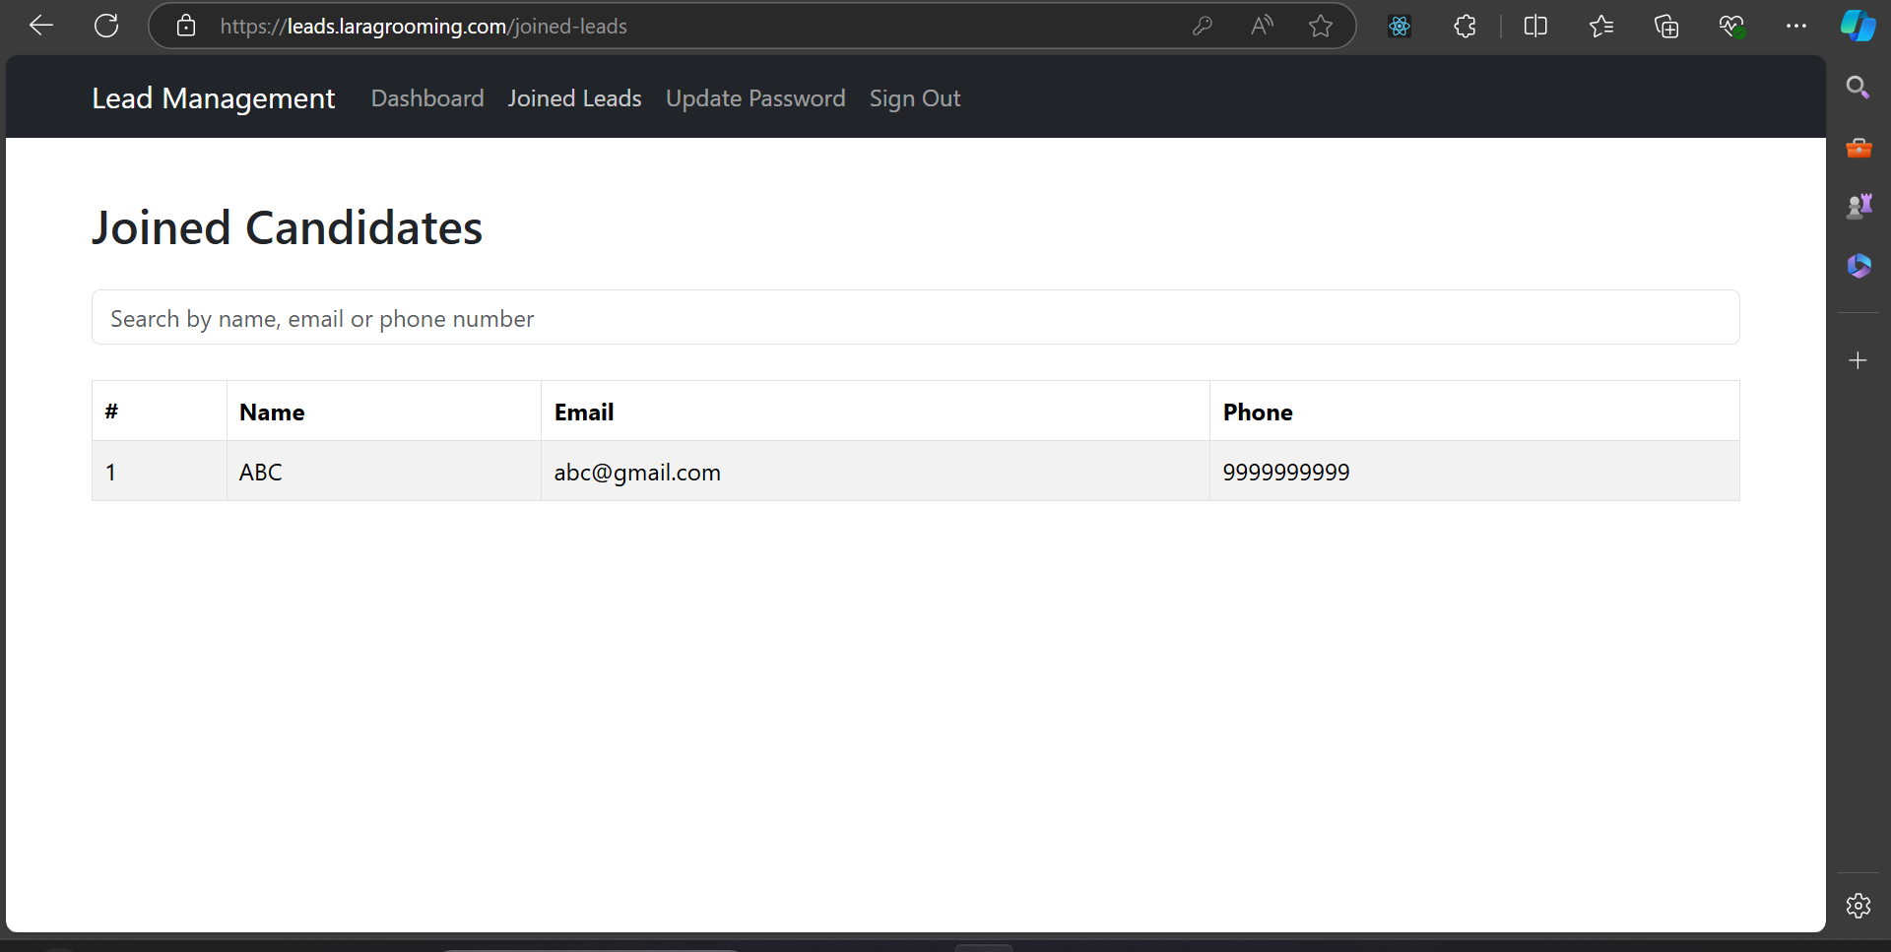

11. Update Password & Counsellor Details
Counsellors can update their login credentials and personal information using the Update Password option available in the navbar.

Update Password
- When a counsellor clicks on Update Password in the navbar, they are redirected to a page with a form to change their current password.
- The password update form contains the following fields:
  - New Password: Input for the new password.
  - Confirm Password: Re-enter the new password for confirmation.
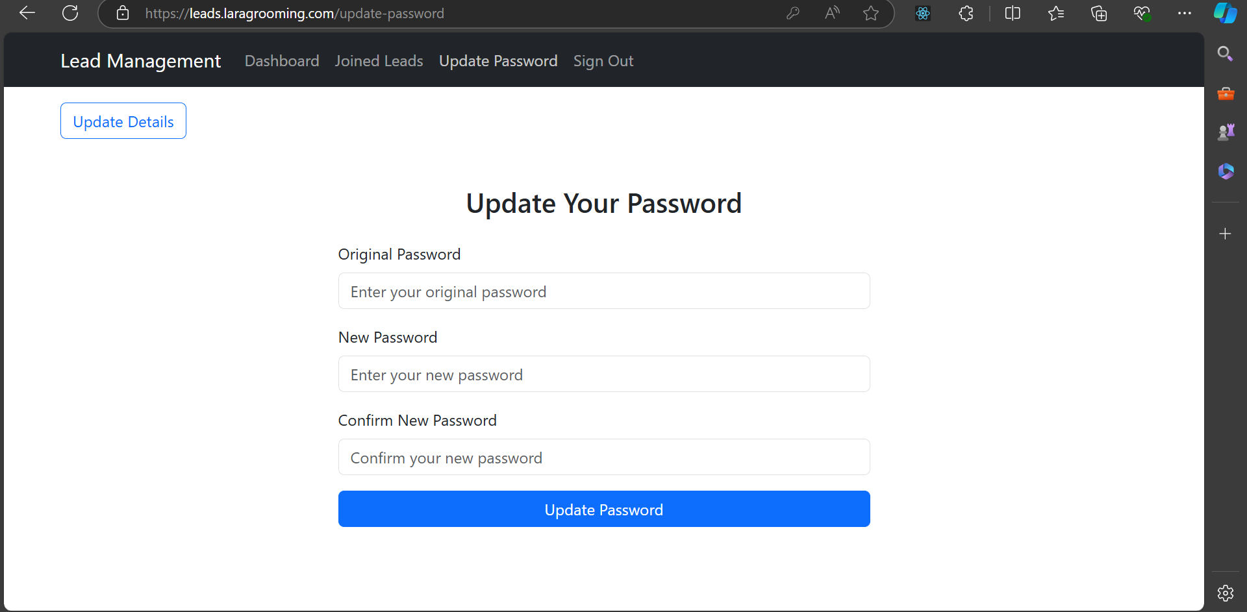
After entering the new password and confirming it, the counsellor can click the Update Password button to securely change their login credentials.

Update Counsellor Details
- In the same Update Password page, a button is provided in the top left corner labeled Update Counsellor Details.
- When the button is clicked, the counsellor is shown a form where they can update their personal information such as:
  - Name
  - Phone
  - Email
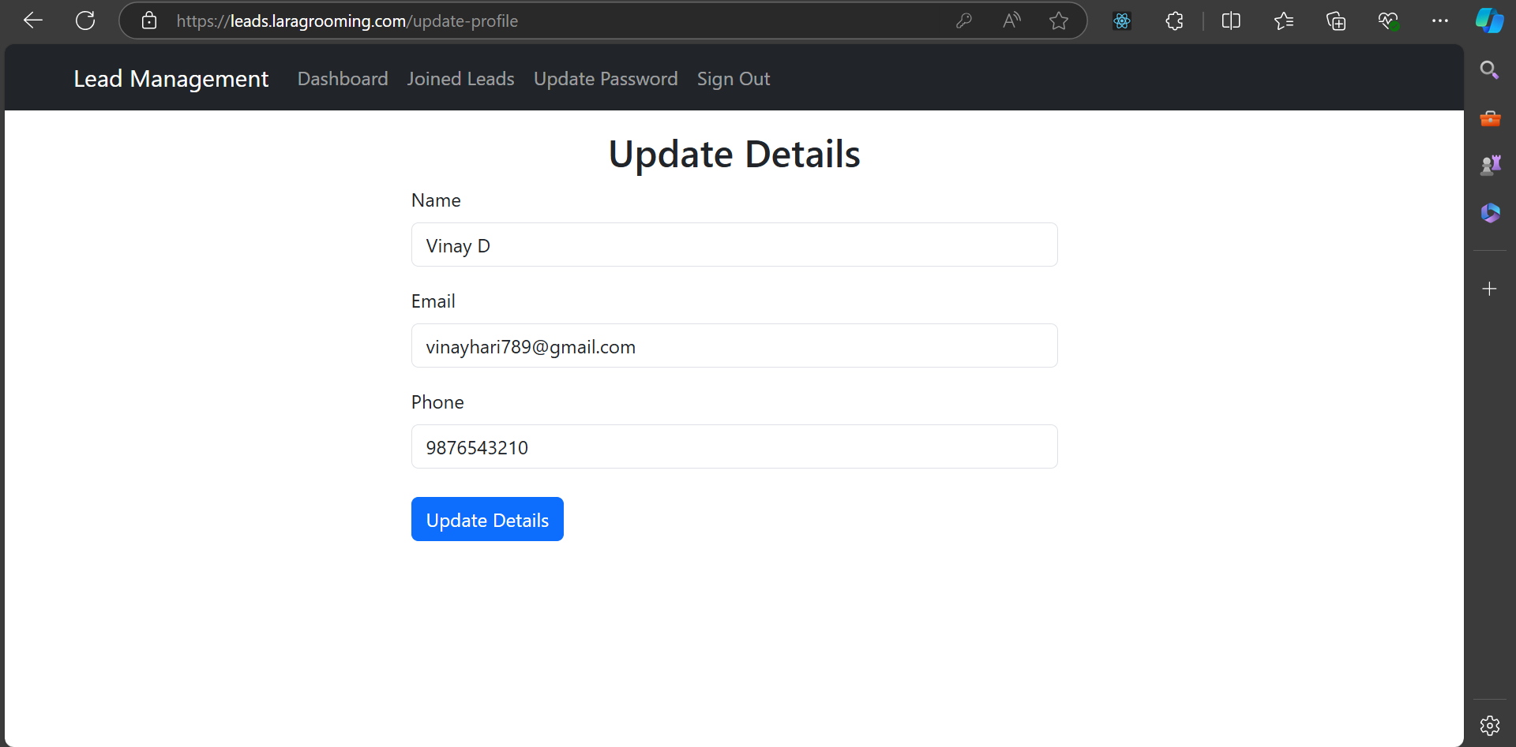
After making changes, the counsellor can submit the form to update their details in the system. This ensures their contact information is always accurate.

